DSA0601 Data Handling and Visualization
Slot A
CO1 – Assessment Test 3 (AT3)
Visualization Design Exercise
Instructions:
For each question, write the program in the specified language (R or Python), generate the required
visualization, and answer the interpretation sub-questions clearly with justification.

NAME: M. Raghavendra
REG.NO:192325022
Question 1
Question
A multinational retail company has collected annual sales information from its branches across different regions. Using the given dataset, design an effective visualization that simultaneously represents Sales, Profit, Number of Customers, Product Category, and Region. Select suitable aesthetic mappings and apply an appropriate scale transformation wherever necessary. Justify every visualization design choice.
R Dataset
retail <- data.frame(
Branch=c("B1","B2","B3","B4","B5","B6","B7","B8","B9","B10",
"B11","B12","B13","B14","B15","B16","B17","B18","B19","B20"), Region=c("North","South","East","West","North","South","East","West", "North","South","East","West","North","South","East","West",
"North","South","East","West"),
Category=c("Electronics","Furniture","Clothing","Food","Electronics", "Furniture","Clothing","Food","Electronics","Furniture",
"Clothing","Food","Electronics","Furniture","Clothing",
"Food","Electronics","Furniture","Clothing","Food"),
Sales=c(450000,620000,180000,920000,350000,720000,250000,1080000, 560000,670000,195000,980000,430000,760000,280000,1150000, 510000,690000,220000,1250000),
Profit=c(45000,95000,-12000,185000,25000,120000,18000,225000,
72000,98000,-8000,205000,51000,132000,24000,250000,
69000,115000,15000,285000),
Customers=c(1200,2500,980,4200,1800,3000,1250,5200,
2100,3300,1100,4700,1750,3600,1450,5600,
2200,3900,1600,6100)
)
Answer to Question 1
Language / libraries: Python 3 (pandas, NumPy, matplotlib). The dataset is re-created exactly as given in the question.
1. Program
# Question 1 - Retail branches: Sales, Profit, Customers, Category, Region
import numpy as np
import pandas as pd
import matplotlib.pyplot as plt
from matplotlib.lines import Line2D
from matplotlib.ticker import FuncFormatter

retail = pd.DataFrame({
"Branch": [f"B{i}" for i in range(1, 21)],
"Region": ["North", "South", "East", "West"] * 5,
"Category": ["Electronics", "Furniture", "Clothing", "Food"] * 5,
"Sales": [450000, 620000, 180000, 920000, 350000, 720000, 250000, 1080000,
560000, 670000, 195000, 980000, 430000, 760000, 280000, 1150000,
510000, 690000, 220000, 1250000],
"Profit": [45000, 95000, -12000, 185000, 25000, 120000, 18000, 225000,
72000, 98000, -8000, 205000, 51000, 132000, 24000, 250000,
69000, 115000, 15000, 285000],
"Customers": [1200, 2500, 980, 4200, 1800, 3000, 1250, 5200,
2100, 3300, 1100, 4700, 1750, 3600, 1450, 5600,
2200, 3900, 1600, 6100],
})
retail["Margin"] = retail.Profit / retail.Sales * 100

# Aesthetic mappings
colour = {"Electronics": "#0072B2", "Furniture": "#E69F00",
"Clothing": "#CC79A7", "Food": "#009E73"} # colour-blind-safe (Okabe-Ito)
shape = {"North": "o", "South": "s", "East": "^", "West": "D"} # shape = Region
AREA = 0.12 # point area per customer

fig, ax = plt.subplots(figsize=(11, 7.2))
ax.axhline(0, color="black", lw=1) # break-even line
xs = np.logspace(np.log10(150000), np.log10(1500000), 100)
for m in (10, 20): # reference profit-margin curves
ax.plot(xs, xs * m / 100, ls="--", lw=0.8, color="grey", zorder=0)
ax.text(1.42e6, 1.42e6 * m / 100, f"{m}% margin", color="grey", fontsize=8, va="center")

for _, r in retail.iterrows():
ax.scatter(r.Sales, r.Profit, s=r.Customers * AREA, marker=shape[r.Region],
color=colour[r.Category], alpha=0.75, edgecolor="black", linewidth=0.7, zorder=3)
ax.annotate(r.Branch, (r.Sales, r.Profit), xytext=(0, 0), textcoords="offset points",
ha="center", va="center", fontsize=6.5, zorder=4)

ax.set_xscale("log") # scale transformation for Sales
ax.set_xlim(150000, 1.6e6)
ax.set_xticks([200000, 300000, 500000, 700000, 1000000, 1400000])
ax.xaxis.set_major_formatter(FuncFormatter(lambda v, p: f"{v/1e6:.1f}M" if v >= 1e6 else f"{v/1e3:.0f}K"))
ax.yaxis.set_major_formatter(FuncFormatter(lambda v, p: f"{v/1e3:.0f}K"))
ax.set_xlabel("Annual Sales (log scale)")
ax.set_ylabel("Annual Profit (linear scale; negative = loss)")
ax.set_title("Retail branches: Sales vs Profit, sized by Customers, coloured by Category, shaped by Region")
ax.grid(alpha=0.25, which="both")

l1 = ax.legend(handles=[Line2D([], [], marker="o", ls="", color=c, markeredgecolor="black", markersize=9, label=k)
for k, c in colour.items()], title="Category (colour)", loc="upper left", fontsize=8)
ax.add_artist(l1)
l2 = ax.legend(handles=[Line2D([], [], marker=m, ls="", color="lightgrey", markeredgecolor="black", markersize=8, label=k)
for k, m in shape.items()], title="Region (shape)", loc="upper left",
bbox_to_anchor=(0.0, 0.76), fontsize=8)
ax.add_artist(l2)
ax.legend(handles=[Line2D([], [], marker="o", ls="", color="lightgrey", markeredgecolor="black",
markersize=np.sqrt(n * AREA), label=f"{n:,}") for n in (1000, 3000, 6000)],
title="Customers (area)", loc="upper left", bbox_to_anchor=(0.0, 0.52), fontsize=8, labelspacing=2.0, borderpad=1.0)
plt.tight_layout()
plt.savefig("q1_visualization.png", dpi=200)

# Supporting summary
print(retail.groupby("Category").agg(Sales=("Sales", "sum"), Profit=("Profit", "sum"),
Customers=("Customers", "sum")).assign(
Margin=lambda d: (d.Profit / d.Sales * 100).round(1)))
print(retail[retail.Profit < 0][["Branch", "Region", "Category", "Sales", "Profit"]])
print(retail.groupby("Category").Margin.agg(["min", "max"]).round(1))
2. Output - Visualization
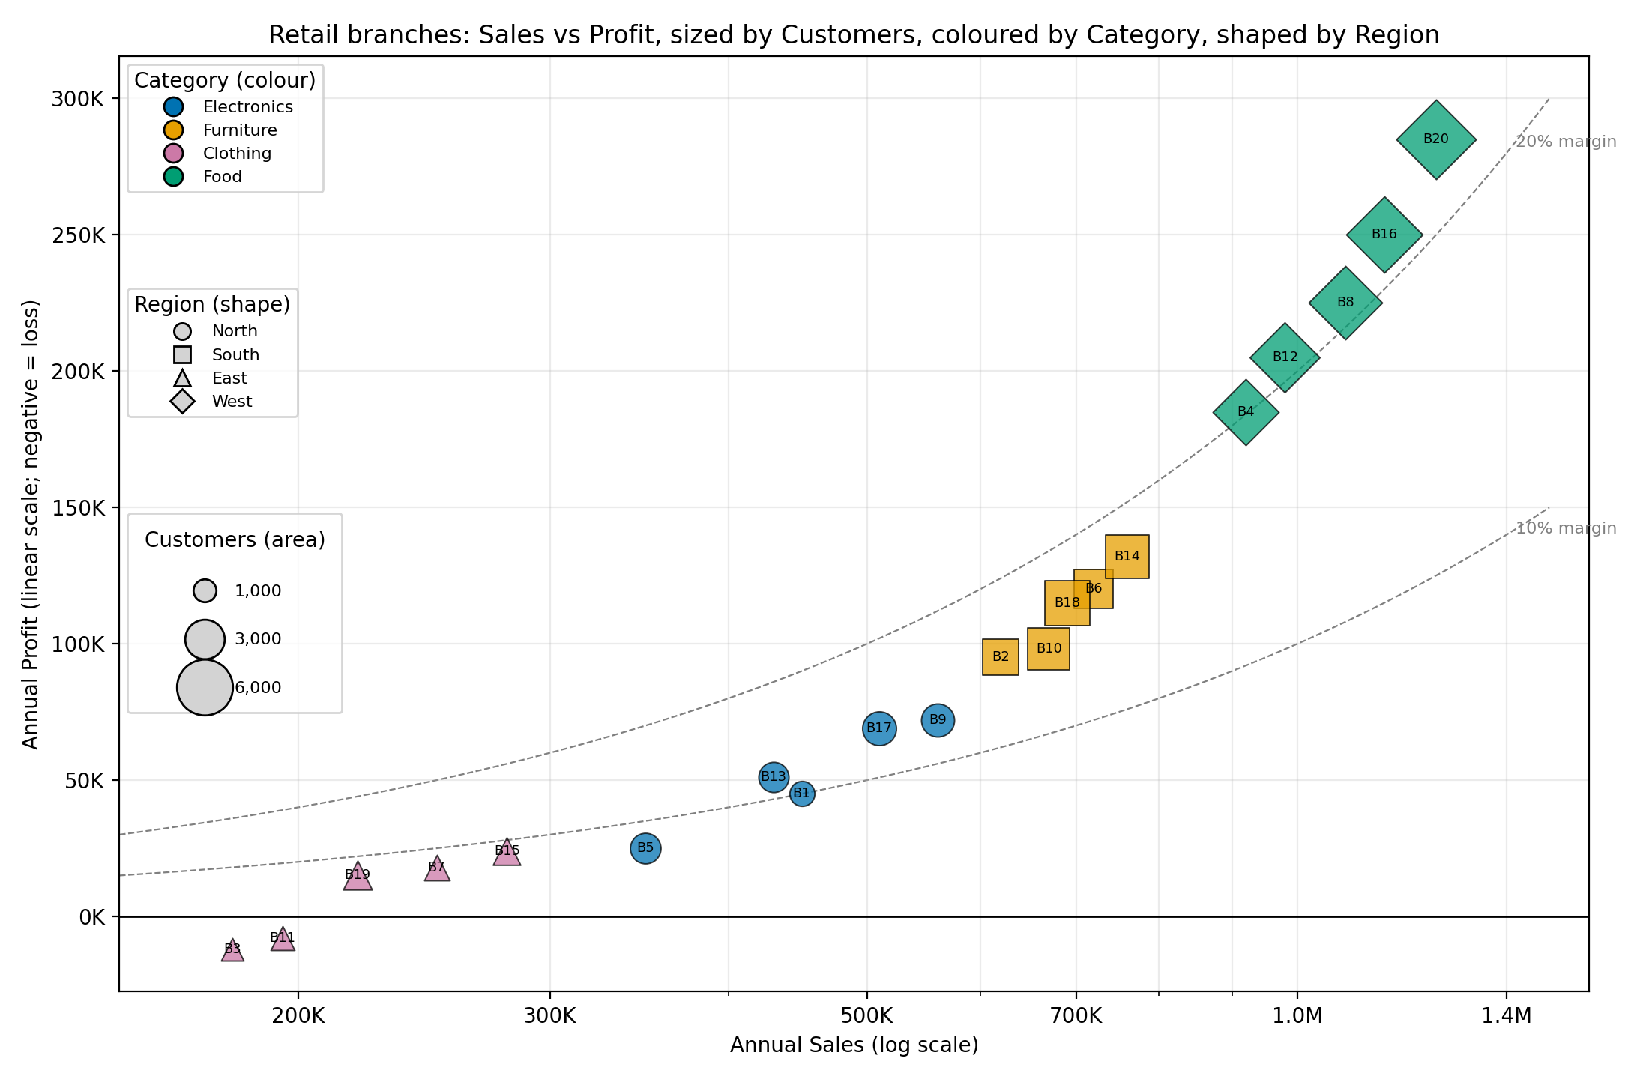
Figure 1: Bubble chart of Sales (log x) vs Profit, with Customers as area, Category as colour and Region as shape.
3. Design Choices and Justification
Variable | Visual channel (aesthetic) | Scale | Justification
Sales | x-position | log10 (transformed) | Sales range from 180K to 1.25M (about 7x). A log axis gives small Clothing branches the same room as large Food branches and makes equal ratios equal distances. Position is the most accurate channel, so it carries the main variable.
Profit | y-position | Linear, with a zero line | Profit contains losses (B3 = -12K, B11 = -8K), so a log scale is impossible. A linear axis with a bold break-even line shows losses clearly below zero.
Customers | Point area | Area proportional to customers (sqrt of radius) | A secondary magnitude; area (not radius) scaling avoids exaggerating large branches. Size legend gives reference values.
Product Category | Colour hue | Qualitative palette (Okabe-Ito, colour-blind safe) | Nominal variable with 4 levels; distinct hues are easy to separate and remain distinguishable for colour-blind viewers.
Region | Marker shape | Circle / square / triangle / diamond | Second nominal variable gets its own channel so it does not compete with colour. In this dataset each region sells one category (North=Electronics, South=Furniture, East=Clothing, West=Food), so shape also reinforces colour and survives greyscale printing.
Helper lines | Dashed curves | 10% and 20% profit margin | Allow margin to be read without adding a sixth variable; they curve on a log x-axis.

4. Interpretation
Food (West) dominates. Food branches form the top-right cluster: total sales 5.38M, profit 1.15M (margin 21.4%) and 25,800 customers, with the largest bubbles (4,200 to 6,100 customers per branch). All four lie on or above the 20% margin curve.
Furniture (South) is second. Sales 3.46M, profit 0.56M (margin 16.2%), sitting between the 10% and 20% curves, with medium-sized bubbles.
Electronics (North) is mid-range. Sales 2.30M, profit 0.26M (margin 11.4%); margins are stable (7.1% to 13.5%) but lower than Furniture and Food.
Clothing (East) is the weak spot. Lowest sales (1.13M), profit only 37K (margin 3.3%) and the smallest customer base (6,380). Branches B3 and B11 are loss-making, the only points below the break-even line; both have sales under 200K.
General pattern. Profit rises faster than sales: moving right on the log axis the points climb above the margin curves, so higher-volume branches are also more profitable. Customer count grows with sales, but electronics earn the most sales per customer (about 254) versus Food (about 208) and Clothing (about 176), so Food wins through volume and margin rather than spend per customer.
Caution. The data have one category per region, so region and category effects cannot be separated.
5. Conclusion
A log-x bubble scatter plot encodes all five variables simultaneously without clutter: position for Sales and Profit, area for Customers, colour for Category and shape for Region. The log transformation of Sales, the linear profit axis with a break-even line, and area-based sizing give an honest picture. It shows that Food branches are the most profitable and largest, while the Clothing branches B3 and B11 need attention.

Question 2
Question
The following dataset contains monthly electricity generation from different energy sources. Develop visualizations using Cartesian Coordinates and Polar Coordinates. Compare both visualizations and determine which coordinate system provides better analytical insight. Explain your design decisions.
R Dataset
energy <- data.frame(
Month=month.abb,
Coal=c(620,580,590,605,640,670,690,720,700,680,650,630),
Gas=c(310,295,305,320,340,355,360,370,365,350,335,320),
Solar=c(45,60,90,130,180,230,250,245,210,160,90,50),
Wind=c(80,95,120,150,170,185,195,190,175,150,110,90),
Hydro=c(140,150,160,170,180,195,205,210,200,185,165,150)
)
Answer to Question 2
Language / libraries: Python 3 (pandas, NumPy, matplotlib). The dataset is re-created exactly as given in the question.
1. Program
# Question 2 - Monthly electricity generation: Cartesian vs Polar coordinates
import numpy as np
import pandas as pd
import matplotlib.pyplot as plt

energy = pd.DataFrame({
"Month": ["Jan", "Feb", "Mar", "Apr", "May", "Jun", "Jul", "Aug", "Sep", "Oct", "Nov", "Dec"],
"Coal": [620, 580, 590, 605, 640, 670, 690, 720, 700, 680, 650, 630],
"Gas": [310, 295, 305, 320, 340, 355, 360, 370, 365, 350, 335, 320],
"Solar": [45, 60, 90, 130, 180, 230, 250, 245, 210, 160, 90, 50],
"Wind": [80, 95, 120, 150, 170, 185, 195, 190, 175, 150, 110, 90],
"Hydro": [140, 150, 160, 170, 180, 195, 205, 210, 200, 185, 165, 150],
})
sources = ["Coal", "Gas", "Solar", "Wind", "Hydro"]
col = {"Coal": "#444444", "Gas": "#E69F00", "Solar": "#F0E442", "Wind": "#56B4E9", "Hydro": "#0072B2"}
mk = {"Coal": "o", "Gas": "s", "Solar": "^", "Wind": "D", "Hydro": "v"}

# ---------- (A) Cartesian coordinates ----------
fig, (a1, a2) = plt.subplots(1, 2, figsize=(13, 5.2))
for s in sources:
a1.plot(energy.Month, energy[s], marker=mk[s], color=col[s], lw=2, label=s,
markeredgecolor="black", markeredgewidth=0.5)
a1.set_title("(a) Line chart - Cartesian: each source on a common baseline")
a1.set_ylabel("Generation (units / month)"); a1.set_xlabel("Month"); a1.grid(alpha=0.3); a1.legend(ncol=5, fontsize=8)
a2.stackplot(energy.Month, [energy[s] for s in sources], labels=sources,
colors=[col[s] for s in sources], edgecolor="white", linewidth=0.5)
a2.set_title("(b) Stacked area - Cartesian: total generation and mix")
a2.set_ylabel("Generation (units / month)"); a2.set_xlabel("Month"); a2.grid(alpha=0.3)
a2.legend(loc="lower center", ncol=5, fontsize=8)
plt.tight_layout(); plt.savefig("q2_cartesian.png", dpi=200); plt.close()

# ---------- (B) Polar coordinates ----------
theta = np.linspace(0, 2 * np.pi, 12, endpoint=False)
fig = plt.figure(figsize=(13, 6.2))
p1 = fig.add_subplot(1, 2, 1, projection="polar")
for s in sources:
v = energy[s].tolist() + [energy[s][0]]
p1.plot(np.append(theta, theta[0]), v, color=col[s], lw=2, label=s, marker=mk[s], markersize=4,
markeredgecolor="black", markeredgewidth=0.4)
p1.fill(np.append(theta, theta[0]), v, color=col[s], alpha=0.12)
p1.set_theta_zero_location("N"); p1.set_theta_direction(-1)
p1.set_xticks(theta); p1.set_xticklabels(energy.Month); p1.set_rlabel_position(200)
p1.set_title("(c) Radar (polar line) chart", pad=18); p1.legend(loc="upper right", bbox_to_anchor=(1.25, 1.1), fontsize=8)

p2 = fig.add_subplot(1, 2, 2, projection="polar")
bottom = np.zeros(12)
for s in sources:
p2.bar(theta, energy[s], width=2 * np.pi / 12 * 0.9, bottom=bottom, color=col[s],
edgecolor="white", linewidth=0.5, label=s)
bottom += energy[s].values
p2.set_theta_zero_location("N"); p2.set_theta_direction(-1)
p2.set_xticks(theta); p2.set_xticklabels(energy.Month); p2.set_rlabel_position(200)
p2.set_title("(d) Stacked polar bars (coxcomb)", pad=18)
plt.tight_layout(); plt.savefig("q2_polar.png", dpi=200); plt.close()

# Supporting numbers
tot = energy[sources].sum(axis=1)
ren = energy[["Solar", "Wind", "Hydro"]].sum(axis=1)
print("Total generation: min", tot.min(), energy.Month[tot.idxmin()], " max", tot.max(), energy.Month[tot.idxmax()])
print("Renewable share % : min", round((ren / tot * 100).min(), 1), energy.Month[(ren / tot).idxmin()],
" max", round((ren / tot * 100).max(), 1), energy.Month[(ren / tot).idxmax()])
for s in sources:
print(s, "peak", energy[s].max(), energy.Month[energy[s].idxmax()], "low", energy[s].min(),
energy.Month[energy[s].idxmin()], "max/min", round(energy[s].max() / energy[s].min(), 2))
print("Annual totals", energy[sources].sum().to_dict())
2. Output - Visualization
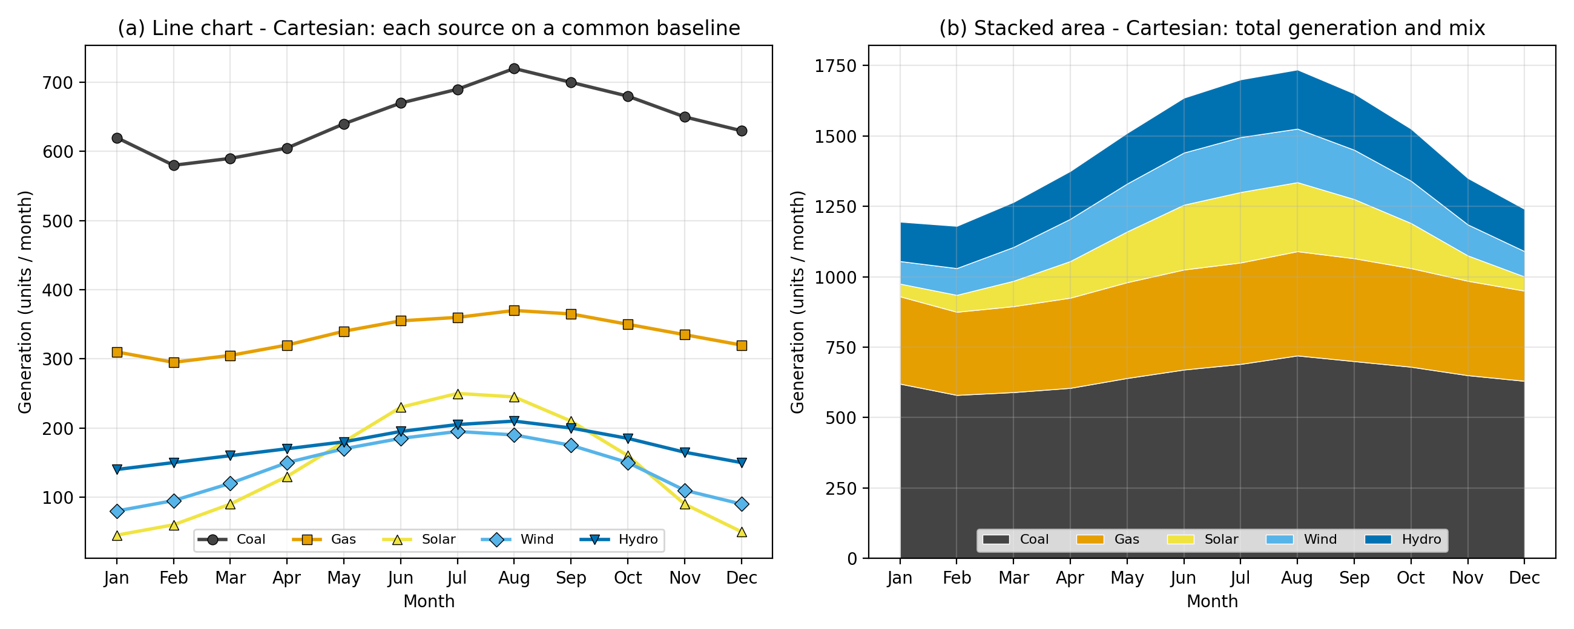
Figure 2a: Cartesian coordinates - line chart (a) and stacked area chart (b).
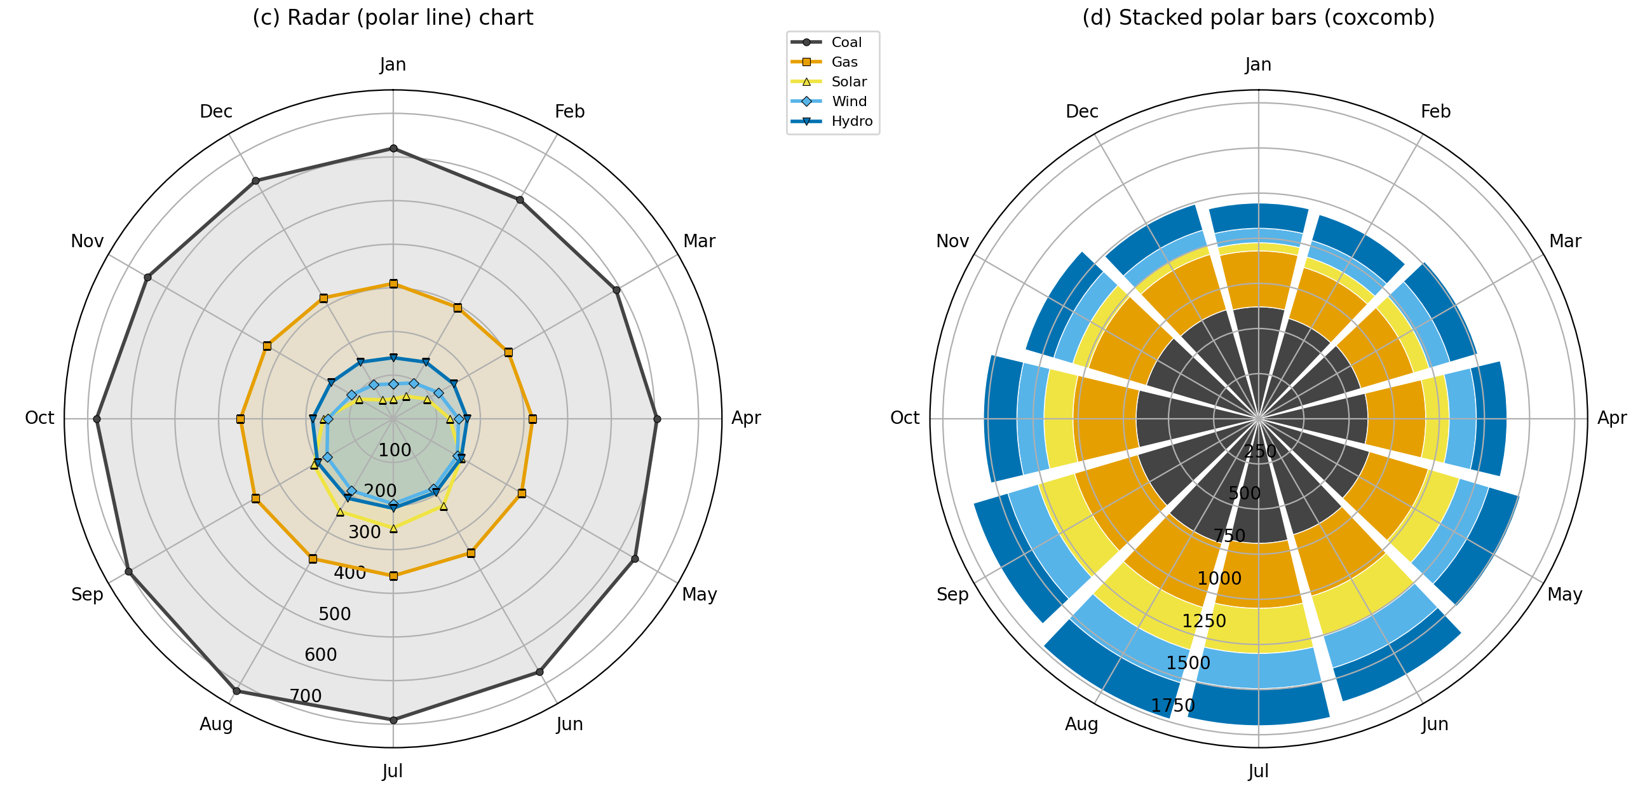
Figure 2b: Polar coordinates - radar chart (c) and stacked polar bars (d).
3. Comparison of the Two Coordinate Systems and Design Decisions
Criterion | Cartesian coordinates | Polar coordinates
Reading exact values | Easy: values read against a common straight baseline and gridlines. | Harder: radial distance and angle must be decoded; no common baseline.
Comparing sources | Lines can be compared by height and slope; Coal (580 to 720) vs Solar (45 to 250) is clear. | Small series (Solar, Wind, Hydro) crowd near the centre and overlap.
Seasonality / cycle | Visible as rise and fall, but Dec and Jan are at opposite ends of the axis. | Excellent: the year is a closed loop, so Dec flows back into Jan and the summer bulge is obvious.
Totals and mix | Stacked area shows total and share clearly (1,180 in Feb to 1,735 in Aug). | Stacked wedges: outer segments occupy more area than inner ones for the same value, distorting perception.
Perceptual accuracy | Position on common scale (most accurate channel). | Angle and area (less accurate); shape of the polygon depends on the order of axes.
Best use | Primary analysis and quantitative comparison. | Supplementary display of cyclic patterns.

4. Interpretation
Seasonal pattern. Every source peaks in the middle of the year (Solar and Wind in July, Coal, Gas and Hydro in August) and falls to its lowest in January or February. Total generation moves from 1,180 in February to 1,735 in August.
Coal dominates. Coal supplies about 45% of annual output (7,775 of 17,360), followed by Gas (4,025), Hydro (2,110), Solar (1,740) and Wind (1,710). Coal and Gas are fairly stable (peak-to-trough ratio about 1.25).
Renewables vary strongly. Solar swings 5.6 times between January (45) and July (250); Wind 2.4 times (80 to 195); Hydro 1.5 times. The renewable share (Solar + Wind + Hydro) rises from 22.2% in January to 38.2% in July.
Cartesian view. The line chart separates the five sources and shows the Solar and Wind rise from April to July; the stacked area shows how the summer rise is carried by renewables while Coal remains a large base.
Polar view. The radar chart makes the annual cycle visually obvious and shows that all sources move together, but Solar, Wind and Hydro are nearly indistinguishable near the centre, and the coxcomb chart exaggerates the outer layers (Hydro looks larger than it is).
5. Conclusion
Cartesian coordinates give better analytical insight: they allow accurate comparison of sources, exact reading of values and clear display of totals and mix. Polar coordinates are useful only as a supplement to emphasise that the data are cyclic. Design decisions: same colour for each source in all charts, colour-blind-safe palette, markers for greyscale reading, zero-based axes, months placed clockwise from the top like a clock in the polar plots, and the polygon closed (Dec to Jan) to reflect continuity of the year.

Question 3
Question
An environmental monitoring agency has collected climate data from major Indian cities. Design a visualization that effectively represents Temperature, Air Quality Index (AQI), Rainfall, and Humidity using appropriate colour scales. Select a suitable colour palette and justify its effectiveness for accurate interpretation and accessibility.
R Dataset
climate <- data.frame(
City=c("Delhi","Mumbai","Chennai","Kolkata","Hyderabad",
"Bangalore","Pune","Ahmedabad","Jaipur","Lucknow",
"Bhopal","Patna","Goa","Kochi","Nagpur","Indore",
"Surat","Visakhapatnam","Coimbatore","Mysuru"),
Temperature=c(44,35,38,40,39,31,33,43,45,39,
38,40,32,30,41,37,36,34,29,28),
Humidity=c(22,84,78,72,48,66,58,26,18,42,
36,45,89,91,30,34,76,82,68,64),
Rainfall=c(6,280,220,190,85,120,95,2,1,35,
48,72,360,410,12,20,180,240,130,145),
AQI=c(365,110,125,180,160,72,84,290,320,240,
175,220,58,52,270,190,145,98,60,55)
)
Answer to Question 3
Language / libraries: Python 3 (pandas, NumPy, matplotlib). The dataset is re-created exactly as given in the question.
1. Program
# Question 3 - Climate of Indian cities: Temperature, AQI, Rainfall, Humidity (colour scales)
import numpy as np
import pandas as pd
import matplotlib.pyplot as plt
from matplotlib.colors import Normalize, PowerNorm

climate = pd.DataFrame({
"City": ["Delhi", "Mumbai", "Chennai", "Kolkata", "Hyderabad", "Bangalore", "Pune", "Ahmedabad", "Jaipur",
"Lucknow", "Bhopal", "Patna", "Goa", "Kochi", "Nagpur", "Indore", "Surat", "Visakhapatnam",
"Coimbatore", "Mysuru"],
"Temperature": [44, 35, 38, 40, 39, 31, 33, 43, 45, 39, 38, 40, 32, 30, 41, 37, 36, 34, 29, 28],
"Humidity": [22, 84, 78, 72, 48, 66, 58, 26, 18, 42, 36, 45, 89, 91, 30, 34, 76, 82, 68, 64],
"Rainfall": [6, 280, 220, 190, 85, 120, 95, 2, 1, 35, 48, 72, 360, 410, 12, 20, 180, 240, 130, 145],
"AQI": [365, 110, 125, 180, 160, 72, 84, 290, 320, 240, 175, 220, 58, 52, 270, 190, 145, 98, 60, 55],
})
df = climate.sort_values("AQI", ascending=False).reset_index(drop=True) # order rows by pollution

# One sequential, perceptually ordered (light -> dark) palette per variable; hue identifies the variable
spec = {"AQI": ("Purples", "AQI (index)"),
"Temperature": ("YlOrRd", "Temperature (°C)"),
"Humidity": ("Blues", "Humidity (%)"),
"Rainfall": ("Greens", "Rainfall (mm, sqrt colour scale)")}

fig, axes = plt.subplots(1, 4, figsize=(11, 8.2), gridspec_kw={"wspace": 0.08})
for ax, (var, (cmap, label)) in zip(axes, spec.items()):
# rainfall is strongly right-skewed -> square-root colour scale so the dry cities remain distinguishable
norm = PowerNorm(0.5, df[var].min(), df[var].max()) if var == "Rainfall" else Normalize(df[var].min(), df[var].max())
cm = plt.get_cmap(cmap)
im = ax.imshow(df[[var]].values, cmap=cmap, norm=norm, aspect="auto")
for i, v in enumerate(df[var]):
r, g, b, _ = cm(norm(v))
lum = 0.2126 * r + 0.7152 * g + 0.0722 * b # choose black/white text for contrast
ax.text(0, i, f"{v:g}", ha="center", va="center", fontsize=9, color="white" if lum < 0.5 else "black")
ax.set_xticks([]); ax.set_title(label, fontsize=10)
ax.set_yticks(range(len(df)))
ax.set_yticklabels(df.City if var == "AQI" else [], fontsize=9)
for s in ax.spines.values():
s.set_visible(False)
ax.set_xticks(np.arange(-.5, 1, 1), minor=True); ax.set_yticks(np.arange(-.5, len(df), 1), minor=True)
ax.grid(which="minor", color="white", lw=1.5); ax.tick_params(which="both", length=0)
cb = fig.colorbar(im, ax=ax, orientation="horizontal", pad=0.03, fraction=0.035)
cb.ax.tick_params(labelsize=7)
fig.suptitle("Climate and air quality of 20 Indian cities (rows sorted by AQI, worst first)", fontsize=12, y=0.95)
plt.savefig("q3_visualization.png", dpi=200, bbox_inches="tight")

print(df.corr(numeric_only=True).round(2))
print(df.head(5)[["City", "AQI", "Temperature", "Humidity", "Rainfall"]])
print(df.tail(5)[["City", "AQI", "Temperature", "Humidity", "Rainfall"]])
2. Output - Visualization
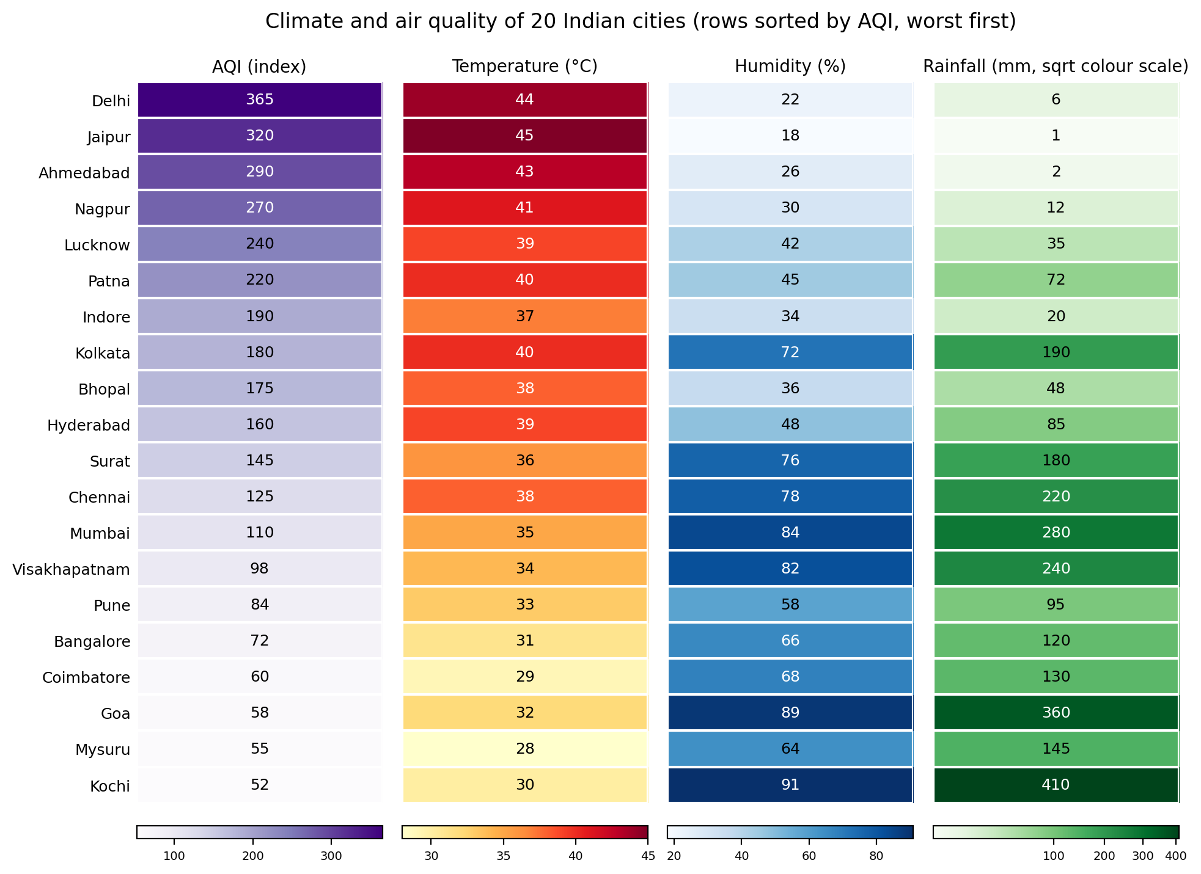
Figure 3: Heat map of AQI, Temperature, Humidity and Rainfall for 20 Indian cities (sorted by AQI).
3. Colour Palette Choice and Justification
Variable | Colour scale | Justification
AQI | Sequential Purples (white to dark purple), linear | A one-direction magnitude (higher = worse); darker = more polluted. Purple/grey avoids the red-green traffic-light scheme that is hard for colour-blind users.
Temperature | Sequential Yellow-Orange-Red, linear | Warm colours match the idea of heat, so the legend is almost self-explanatory.
Humidity | Sequential Blues, linear | Blue is the natural association with moisture.
Rainfall | Sequential Greens, square-root scale | Rainfall is right-skewed (1 to 410 mm, median about 108); a square-root colour scale keeps dry cities (1 to 35 mm) distinguishable instead of all looking white.
All | Light to dark lightness ordering; values printed in cells; separate colour bar per variable; text colour switches black/white for contrast | Lightness alone orders the values, so the chart still works in greyscale and for colour-vision deficiency. Different hues prevent mixing up variables; printed numbers allow exact reading. Rainbow/jet palettes were avoided because they have no natural order and create false boundaries.

4. Interpretation
Hot and dry cities have the worst air. Delhi (AQI 365, 44 C, 22% humidity, 6 mm rain), Jaipur (320, 45 C, 18%, 1 mm) and Ahmedabad (290, 43 C, 26%, 2 mm) show dark purple and dark red together with pale blue and pale green cells.
Humid, rainy coastal and southern cities have the cleanest air. Kochi (AQI 52, 91% humidity, 410 mm), Goa (58, 89%, 360 mm), Mysuru (55) and Coimbatore (60) have pale purple but dark blue/green cells.
Strength of association. AQI is strongly positively related to temperature (r = 0.94) and negatively to humidity (r = -0.85) and rainfall (r = -0.73); humidity and rainfall are themselves strongly related (r = 0.93).
Exceptions. Kolkata (AQI 180 despite 72% humidity and 190 mm) and Patna (AQI 220 with moderate humidity) show that other factors such as emissions and geography also matter. These associations do not prove causation.
Accessibility. Sequential single-hue ramps, redundant numeric labels and a separate colour bar for each variable make the heat map readable for colour-blind readers and in black-and-white print.
5. Conclusion
A city-by-variable heat map with one perceptually ordered sequential palette per variable, a square-root scale for skewed rainfall, and printed values communicates all four variables accurately and accessibly. It reveals a clear north-west hot-dry/high-AQI group versus a southern and coastal humid-rainy/low-AQI group.

Question 4
Question
A software company has recorded project statistics for twenty software development teams. Design a visualization that requires the use of a nonlinear axis transformation to represent highly skewed data. Justify the selected transformation and explain how it improves interpretation over a linear scale.
R Dataset
software <- data.frame(
Team=paste("T",1:20,sep=""),
LinesOfCode=c(12000,18000,25000,35000,48000,
62000,81000,96000,120000,150000,
185000,240000,310000,390000,480000,
620000,810000,1050000,1350000,1800000),
Bugs=c(35,52,60,72,88,
110,125,142,165,188,
205,240,280,320,365,
420,490,560,640,720),
Developers=c(5,7,9,10,12,
14,16,18,20,22,
25,28,30,34,38,
42,46,50,55,60),
Complexity=c(2.1,2.4,2.7,3.0,3.2,
3.5,3.8,4.1,4.5,4.8,
5.1,5.4,5.8,6.2,6.6,
7.1,7.6,8.0,8.5,9.0)
)
Answer to Question 4
Language / libraries: Python 3 (pandas, NumPy, matplotlib, SciPy). The dataset is re-created exactly as given in the question.
1. Program
# Question 4 - Software teams: nonlinear (log) axis transformation for highly skewed data
import numpy as np
import pandas as pd
import matplotlib.pyplot as plt
from matplotlib.lines import Line2D
from matplotlib.ticker import FuncFormatter
from scipy.stats import skew

software = pd.DataFrame({
"Team": [f"T{i}" for i in range(1, 21)],
"LinesOfCode": [12000, 18000, 25000, 35000, 48000, 62000, 81000, 96000, 120000, 150000,
185000, 240000, 310000, 390000, 480000, 620000, 810000, 1050000, 1350000, 1800000],
"Bugs": [35, 52, 60, 72, 88, 110, 125, 142, 165, 188, 205, 240, 280, 320, 365, 420, 490, 560, 640, 720],
"Developers": [5, 7, 9, 10, 12, 14, 16, 18, 20, 22, 25, 28, 30, 34, 38, 42, 46, 50, 55, 60],
"Complexity": [2.1, 2.4, 2.7, 3.0, 3.2, 3.5, 3.8, 4.1, 4.5, 4.8, 5.1, 5.4, 5.8, 6.2, 6.6, 7.1, 7.6, 8.0, 8.5, 9.0],
})
sz = lambda d: d * 14 # area ~ Developers

fig, (a, b) = plt.subplots(1, 2, figsize=(13, 5.8))
for ax in (a, b):
sc = ax.scatter(software.LinesOfCode, software.Bugs, s=sz(software.Developers), c=software.Complexity,
cmap="viridis", edgecolor="black", linewidth=0.6, alpha=0.85, zorder=3)
ax.grid(alpha=0.3, which="both"); ax.set_ylabel("Bugs")
ax.xaxis.set_major_formatter(FuncFormatter(lambda v, p: f"{v/1e6:g}M" if v >= 1e6 else f"{v/1e3:g}K"))
a.set_xlabel("Lines of code (linear)"); a.set_title("(a) Linear axes: small teams are squeezed into one corner")
for t in ("T1", "T10", "T20"):
r = software[software.Team == t].iloc[0]; a.annotate(t, (r.LinesOfCode, r.Bugs), xytext=(6, 6), textcoords="offset points", fontsize=8)

b.set_xscale("log"); b.set_yscale("log") # nonlinear transformation on both axes
b.set_xlabel("Lines of code (log10 scale)"); b.set_ylabel("Bugs (log10 scale)")
b.set_title("(b) Log-log axes: even spread, straight-line trend")
slope, intercept = np.polyfit(np.log10(software.LinesOfCode), np.log10(software.Bugs), 1)
r2 = np.corrcoef(np.log10(software.LinesOfCode), np.log10(software.Bugs))[0, 1] ** 2
xs = np.logspace(np.log10(10000), np.log10(2.2e6), 50)
b.plot(xs, 10 ** intercept * xs ** slope, "k--", lw=1, label=f"Power law: Bugs = {10**intercept:.3f} x LOC^{slope:.2f} (R² = {r2:.3f})")
b.legend(loc="upper left", fontsize=8)
b.set_yticks([30, 50, 100, 200, 400, 700]); b.yaxis.set_major_formatter(FuncFormatter(lambda v, p: f"{v:g}"))
for t in ("T1", "T10", "T20"):
r = software[software.Team == t].iloc[0]; b.annotate(t, (r.LinesOfCode, r.Bugs), xytext=(6, -12), textcoords="offset points", fontsize=8)
cb = fig.colorbar(sc, ax=[a, b], pad=0.02, fraction=0.03); cb.set_label("Complexity (colour)")
h = [Line2D([], [], marker="o", ls="", color="lightgrey", markeredgecolor="black", markersize=np.sqrt(sz(n)), label=f"{n} developers") for n in (10, 30, 60)]
a.legend(handles=h, loc="upper left", fontsize=8, labelspacing=1.4, borderpad=1.0)
plt.savefig("q4_visualization.png", dpi=200, bbox_inches="tight")

print("skewness LOC", round(skew(software.LinesOfCode), 2), " skewness Bugs", round(skew(software.Bugs), 2))
print("LOC max/min", software.LinesOfCode.max() / software.LinesOfCode.min(), " median", software.LinesOfCode.median(),
" mean", software.LinesOfCode.mean(), " teams <250K:", (software.LinesOfCode < 250000).sum())
print("slope", round(slope, 3), "R2", round(r2, 4), "log-log; log10(LOC) skew", round(skew(np.log10(software.LinesOfCode)), 2))
print("linear r2", round(np.corrcoef(software.LinesOfCode, software.Bugs)[0, 1] ** 2, 3))
print("bugs per KLOC T1", 35 / 12, "T20", 720 / 1800)
2. Output - Visualization
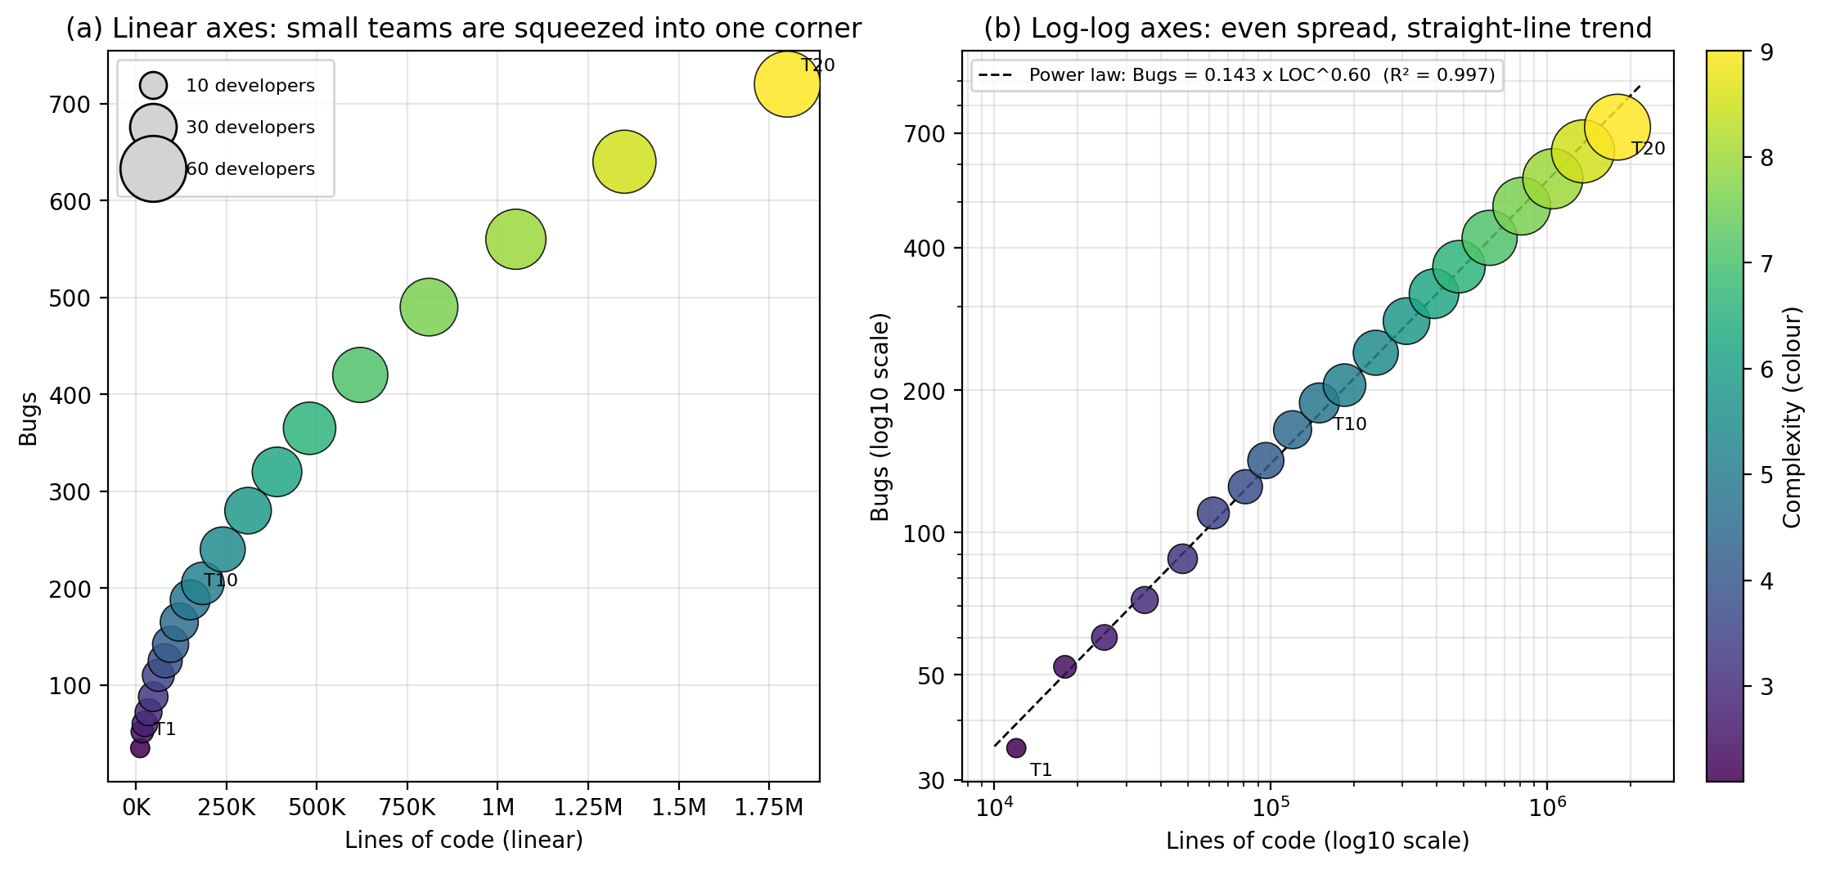
Figure 4: Linear axes (a) versus log-log axes (b) for LinesOfCode vs Bugs, with Developers as size and Complexity as colour.
3. Selected Transformation and Justification
Item | Choice | Reason
Transformation | log10 on LinesOfCode (x) and Bugs (y) | LinesOfCode ranges from 12,000 to 1,800,000 (150x) with skewness 1.58 (mean 394,100 vs median 167,500; 12 of 20 teams below 250K). After log10 the skewness is -0.10. Bugs (35 to 720) are also multiplicative in nature.
Why log, not sqrt | Equal distance = equal percentage change | Software metrics grow multiplicatively; a power-law relation Bugs = a x LOC^b becomes a straight line on log-log axes. Sqrt or other mild transforms would still leave small teams crowded.
Developers | Point area | Third quantitative variable; area scaling.
Complexity | Viridis colour (sequential, colour-blind safe) | Fourth quantitative variable, ordered light-to-dark.
Comparison panel | Linear plot beside log-log plot | Same encodings in both panels so the benefit of the transformation is directly visible.

4. Interpretation
Linear scale problem. In panel (a) twelve small teams are squashed into the lower-left corner; teams T1 to T10 cannot be separated, and the few huge teams (T18 to T20) dominate the visual.
Log-log improvement. In panel (b) the points are evenly spread and fall on a nearly straight line. The fitted power law is Bugs = 0.143 x LOC^0.60 with R2 = 0.997 (linear-scale fit R2 = 0.938), so the relationship is far better captured.
Meaning of the slope. The exponent 0.60 is below 1: doubling the code size multiplies bugs by about 1.5 (2^0.6), not 2. Bug density therefore falls with size, from 2.9 bugs per KLOC for T1 to 0.4 for T20.
Other variables. Larger teams have more developers (bigger bubbles) and higher complexity (yellower colour) in a smooth progression, because all variables rise with size; their separate effects cannot be isolated from this data.
Caution. Log axes show proportional rather than absolute differences, so axes must be clearly labelled; log scales work here because all values are positive.
5. Conclusion
A log10 (log-log) transformation is appropriate for the highly skewed software data. It removes overplotting of small teams, shows the true proportional relationship as a straight line (power law with exponent about 0.6), and reveals that bugs grow less than proportionally with code size - information hidden on the linear scale.

Question 5
Question
A financial analytics company has collected performance data for twenty publicly listed companies. Develop an integrated visualization that effectively communicates Revenue, Profit Margin, Market Capitalization, Employee Strength, and Industry Sector. Use appropriate aesthetic mappings, coordinate systems, scales, and colour palettes to maximise interpretability while minimising perceptual bias.
R Dataset
companies <- data.frame(
Company=paste("C",1:20,sep=""),
Sector=c("IT","Banking","Healthcare","Retail","Energy",
"IT","Banking","Healthcare","Retail","Energy",
"IT","Banking","Healthcare","Retail","Energy",
"IT","Banking","Healthcare","Retail","Energy"),
Revenue=c(420,580,720,850,980,
1150,1320,1480,1650,1820,
2050,2280,2550,2840,3150,
3480,3860,4250,4680,5200),
ProfitMargin=c(8.2,15.6,11.4,9.3,18.5,
20.4,17.8,14.2,10.5,22.1,
24.5,19.8,16.7,13.4,26.2,
28.1,21.5,18.3,15.2,30.4),
Employees=c(1500,3200,2100,4200,2800,
5100,6800,3900,7200,4500,
8100,9500,6200,10300,7200,
11800,13200,8600,14500,16000),
MarketCap=c(8500,12000,9800,7600,14500, 18200,21500,16800,13200,24500, 28500,32500,24800,19200,38200, 42500,46800,35600,29800,52000) )
Answer to Question 5
Language / libraries: Python 3 (pandas, NumPy, matplotlib). The dataset is re-created exactly as given in the question.
1. Program
# Question 5 - Listed companies: Revenue, Profit Margin, Market Cap, Employees, Sector
import numpy as np
import pandas as pd
import matplotlib.pyplot as plt
from matplotlib.lines import Line2D
from matplotlib.ticker import FuncFormatter

companies = pd.DataFrame({
"Company": [f"C{i}" for i in range(1, 21)],
"Sector": ["IT", "Banking", "Healthcare", "Retail", "Energy"] * 4,
"Revenue": [420, 580, 720, 850, 980, 1150, 1320, 1480, 1650, 1820,
2050, 2280, 2550, 2840, 3150, 3480, 3860, 4250, 4680, 5200],
"ProfitMargin": [8.2, 15.6, 11.4, 9.3, 18.5, 20.4, 17.8, 14.2, 10.5, 22.1,
24.5, 19.8, 16.7, 13.4, 26.2, 28.1, 21.5, 18.3, 15.2, 30.4],
"Employees": [1500, 3200, 2100, 4200, 2800, 5100, 6800, 3900, 7200, 4500,
8100, 9500, 6200, 10300, 7200, 11800, 13200, 8600, 14500, 16000],
"MarketCap": [8500, 12000, 9800, 7600, 14500, 18200, 21500, 16800, 13200, 24500,
28500, 32500, 24800, 19200, 38200, 42500, 46800, 35600, 29800, 52000],
})
pal = {"IT": "#0072B2", "Banking": "#E69F00", "Healthcare": "#009E73", "Retail": "#CC79A7", "Energy": "#D55E00"}
AREA = 0.022 # point area per unit of market cap

fig, (a, b) = plt.subplots(1, 2, figsize=(14, 7), gridspec_kw={"width_ratios": [1.7, 1], "wspace": 0.12})
# (A) Cartesian bubble chart
a.scatter(companies.Revenue, companies.ProfitMargin, s=companies.MarketCap * AREA,
c=companies.Sector.map(pal), alpha=0.8, edgecolor="black", linewidth=0.7, zorder=3)
for _, r in companies.iterrows():
a.annotate(r.Company, (r.Revenue, r.ProfitMargin), ha="center", va="center", fontsize=7, zorder=4)
a.set_xscale("log"); a.set_xticks([500, 1000, 2000, 4000]); a.xaxis.set_major_formatter(FuncFormatter(lambda v, p: f"{v:,.0f}"))
a.set_xlim(330, 6800); a.set_ylim(5, 33)
a.set_xlabel("Revenue (log scale)"); a.set_ylabel("Profit margin (%)")
a.set_title("(A) Revenue vs Profit margin; bubble area = Market cap; colour = Sector")
a.grid(alpha=0.3, which="both")
h1 = [Line2D([], [], marker="o", ls="", color=c, markeredgecolor="black", markersize=9, label=k) for k, c in pal.items()]
l1 = a.legend(handles=h1, title="Sector (colour)", loc="lower right", fontsize=8); a.add_artist(l1)
a.legend(handles=[Line2D([], [], marker="o", ls="", color="lightgrey", markeredgecolor="black",
markersize=np.sqrt(n * AREA), label=f"{n:,}") for n in (10000, 30000, 50000)],
title="Market cap (area)", loc="upper left", fontsize=8, labelspacing=1.6, borderpad=1.0)

# (B) Employee strength, same companies, same colours (ordered by revenue)
y = np.arange(len(companies))[::-1]
b.hlines(y, 0, companies.Employees, color=companies.Sector.map(pal), lw=2.5)
b.scatter(companies.Employees, y, c=companies.Sector.map(pal), s=45, edgecolor="black", zorder=3)
b.set_yticks(y); b.set_yticklabels(companies.Company, fontsize=8)
b.set_xlabel("Employees (linear scale, zero baseline)"); b.set_title("(B) Employee strength (companies ordered by revenue)")
b.xaxis.set_major_formatter(FuncFormatter(lambda v, p: f"{v/1e3:g}K")); b.grid(axis="x", alpha=0.3)
plt.savefig("q5_visualization.png", dpi=200, bbox_inches="tight")

# Supporting numbers
c = companies
print(c[["Revenue", "ProfitMargin", "MarketCap", "Employees"]].corr().round(2))
print(c.groupby("Sector").agg(Revenue=("Revenue", "sum"), Margin=("ProfitMargin", "mean"), Cap=("MarketCap", "sum"),
Emp=("Employees", "sum")).round(1))
c["RevPerEmp"] = c.Revenue / c.Employees * 1000
print(c.groupby("Sector").RevPerEmp.mean().round(1))
print("Cap/Revenue", (c.MarketCap / c.Revenue).describe().round(1))
print("log-corr rev-margin", round(np.corrcoef(np.log10(c.Revenue), c.ProfitMargin)[0, 1], 2))
2. Output - Visualization
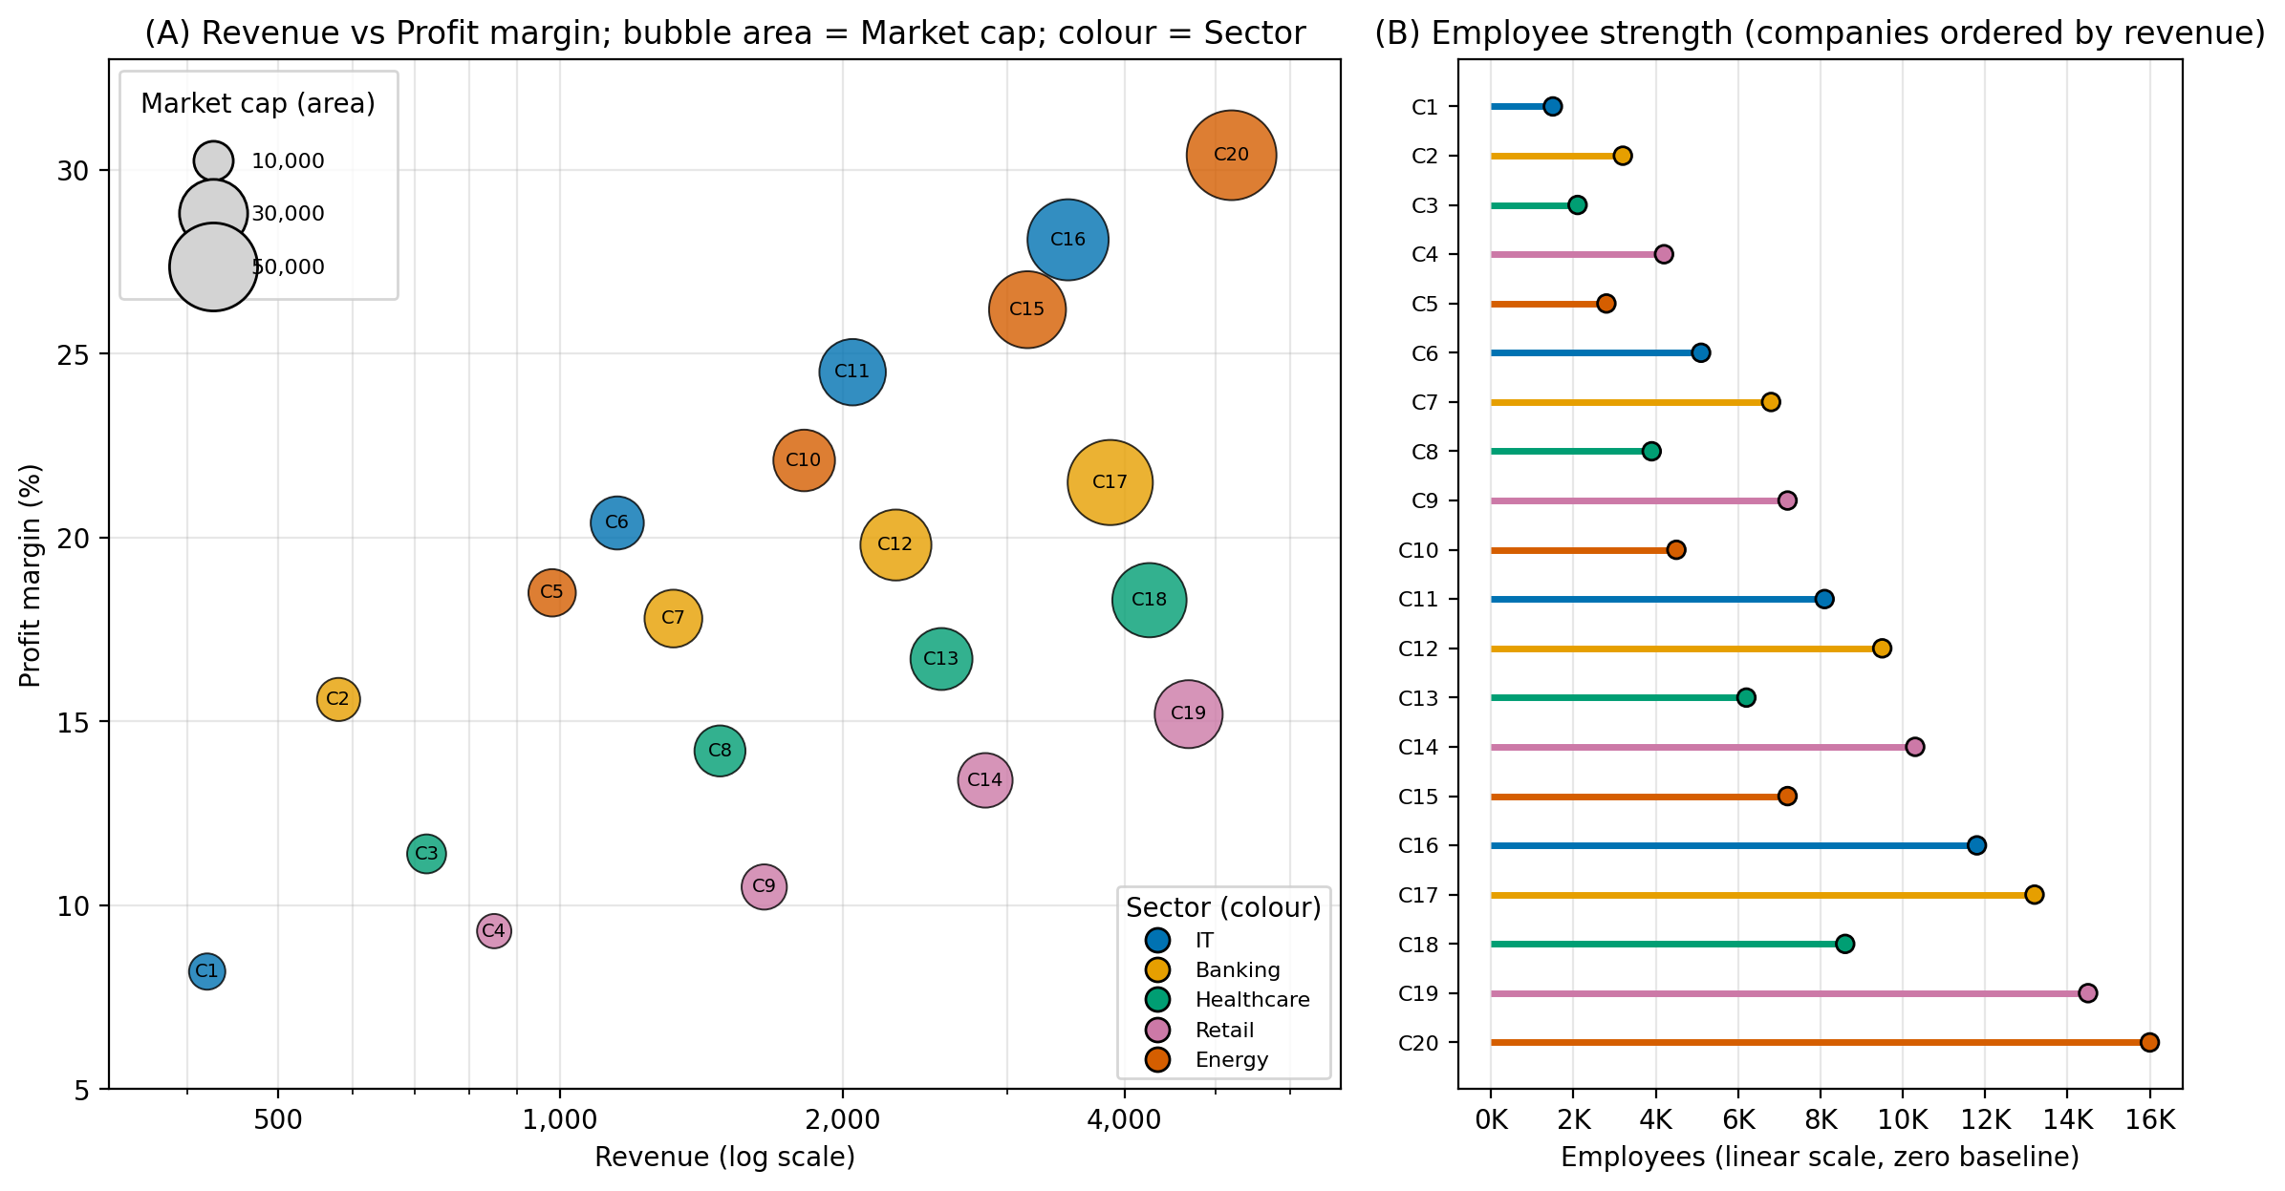
Figure 5: Integrated view - (A) Revenue (log) vs Profit margin with Market cap as area and Sector as colour; (B) Employees by company.
3. Aesthetic Mappings, Scales, Coordinate Systems and Colours
Variable | Visual channel | Scale / coordinate system | Justification
Revenue | x-position (Panel A) | Cartesian, log scale | Revenue spans 420 to 5,200 (12x); log spreads small firms and gives equal ratios equal distances.
Profit Margin | y-position (Panel A) | Cartesian, linear (8% to 30%) | A percentage with a limited range; position gives accurate reading.
Market Cap | Bubble area (Panel A) | Area proportional to value (sqrt radius) | Magnitude variable; area scaling avoids the over-estimation that radius scaling causes; legend shows 10,000 / 30,000 / 50,000.
Industry Sector | Colour hue (both panels) | Qualitative Okabe-Ito palette | Nominal variable; distinct hues, colour-blind safe, and the same colours link both panels. No continuous or rainbow colours are used for categories.
Employees | Bar/lollipop length (Panel B) | Cartesian, linear, zero baseline | A quantitative variable is best shown with position/length, the most accurate channels, rather than a fifth weak channel (opacity, shape). A zero baseline avoids bias in length comparison; company labels connect to Panel A.
Minimising bias | - | No 3D, no polar | Cartesian coordinates avoid angle/area distortion; transparency (alpha 0.8) reveals overlap; the same company labels C1 to C20 appear in both panels.

4. Interpretation
Size and profitability go together. Revenue is positively related to profit margin (r = 0.58; 0.62 with log revenue) - larger firms (C15 to C20) generally earn higher margins; C20 combines the highest revenue (5,200), highest margin (30.4%) and the largest market cap (52,000).
Market valuation. Market cap correlates strongly with revenue (r = 0.88) and also with margin (r = 0.84), so investors value both scale and profitability; market cap is about 12.5 times revenue on average (range 6.4 to 20.7).
Employees. Employee numbers rise almost in line with revenue (r = 0.91), from 1,500 (C1) to 16,000 (C20).
Sector differences. Energy has the highest average margin (24.3%) and the largest total market cap (129,200); Retail has the lowest average margin (12.1%) but the most employees in total (36,200), i.e. a labour-intensive, low-margin sector (C19: 14,500 employees, margin 15.2%). Healthcare has the highest revenue per employee (about 407 per 1,000 employees) and Banking the lowest (about 227).
Caution. Each sector has only four companies, so sector averages are indicative, not conclusive.
5. Conclusion
The integrated two-panel design shows all five variables: panel A uses a log-x Cartesian bubble chart (Revenue, Profit Margin, Market Cap, Sector) and panel B uses a linear zero-based lollipop chart for Employees linked by company labels and sector colour. Area scaling, colour-blind-safe categorical colours, a log scale only where the data are skewed, and Cartesian coordinates keep perceptual bias low.

